Hpsdt-=0p=hs8(Sun blessed Juice) Sunblessed Juice Company sells bags of oranges and cartons of orange juice. Sunblessed grades oranges on a scale of 1 (poor) to 10 (excellent). At present, Sunblessed has 220,000 pounds of grade 6 oranges and 150,000 pounds of grade 9 oranges on hand. The average quality of oranges sold in bags must be at least 7, and the average quality of the oranges used to produce orange juice must be at least 8. Each pound of oranges that is used for juice yields a revenue of $2.25 and incurs a variable cost (consisting of labor costs, variable overhead costs, inventory costs, and so on) of $1.35. Each pound of oranges sold in bags yields a revenue of $2.00 and incurs a variable cost of $1.20. Determine how Sunblessed can maximize its profit.

**Discussion: -**

As highlighted in NewAge pharmaceutical problem, we must blend various inputs together to produce desired outputs. In this problem we have two types of Oranges (Quality level is different) and company generates revenue by selling them through two channels (Bags of oranges, cartons of juice). Below picture illustrates the same and highlights the decision variable. We can understand form below diagram that we can uses any type of oranges to produce these two products (Bags / Juice), our constraint is to maintain the quality of the output. Our problem is to maximize the profit by selling the Oranges available. Each pound of the oranges used for preparing the product yields certain amount of revenue and incurs certain amount of cost, through which we can calculate the profit generated from the output using the 1 pound of input. So, our decision variable should be the quantity of inputs used to produce the output.

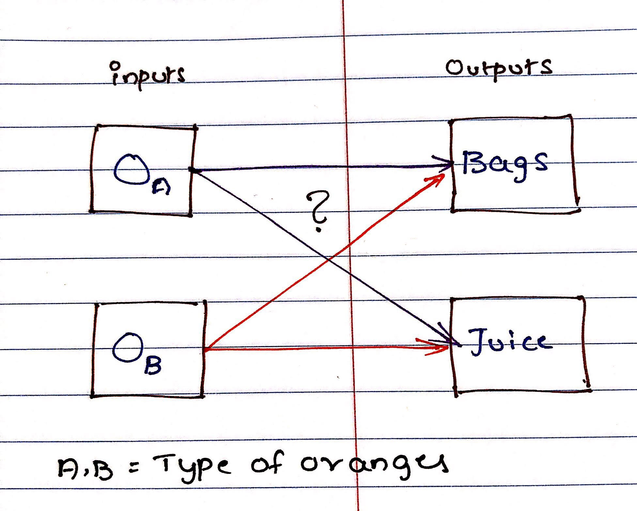

Our main concern in the problem is maintaining the quality, let’s do a simple mathematical problem using the mixture concepts. Below picture gives you a simple math explaining how we can maintain the quality of product sold in bangs. $O_{A.Bags},O_{B.Bags}$ is the quantity of different type of oranges used for production of product sold in bag.

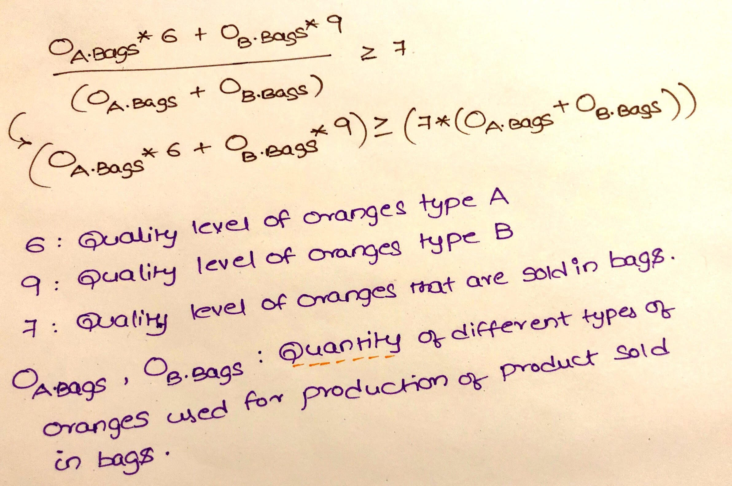

**Mathematical Model: -**

*Parameters (Inputs):*

$$i ϵ 1,2 \left( i: Index for type of oranges\right)$$

$$j ϵ 1,2 \left( i: Index for outputs sold through \left(Bags,Juice\right)\right)$$

$$Q_{i} :Quality levels of type i oranges$$

$$Q_{j} :Quality level required to produce product j$$

$$R_{j} :Revenue from 1 lb of oranges by producing product j$$

$$C_{j} :Cost for 1 lb of oranges to produce product j$$

$$O_{i} :Available quantity of type i oranges$$

*Decision Variables:*

$$x_{ij} :Oranges type i used for producing output j$$

*Objective:*

$$Maximize the profit=\sum_{i=1}^{2}{\sum_{j=1}^{2}{x_{ij}*(R_{j}}}-C_{j})$$

*Constraints:*

$$x_{ij}≥0; \left(1\right) Non Negative constraint$$

$$\sum_{j=1}^{2}{x_{ij}}≤O_{i} ; for iϵ\left\{1,2\right\} \left(2\right) Quantity of oranges available$$

$$\sum_{i=1}^{2}{x_{ij}}*Q_{i} ≥\sum_{i=1}^{2}{x_{ij}}*Q_{j} ; for jϵ\left\{1,2\right\} \left(3\right) Quality of output product$$

*Excel Implementation:* Please find the attached spreadsheet for solution.

